National Dance Council of Kazakhstan
Kazakhstan Dance Union (KDU)

World festival of Ballroom Dancing
«Silk Way»
IDSA Cup
Juniors 12-15 years old
Adults 16 years old and older
Eurasia open
May 10-11, Astana, Kazakhstan

"Silk Way" World festival of Ballroom Dancing is an international championship (Festival onwards) held with a view to popularize sports and ballroom dancing and develop the creativity among youth; find and support talented children and perspective collectives of dancing sport; develop the finest traditions of dancing sport as an essential part of folk art culture; raise youth in the spirit of tolerance and interest to other cultures and share experience among collectives and educators of different countries.
This project is first in its kind to be held in Kazakhstan as well as in the whole world dancing society. "Silk Way" is an innovative project in developing of dancing art. It covers countries of the Great Silk Way, developing the finest cultural traditions of such countries as Kazakhstan, Japan, China, South Korea, Uzbekistan, Kyrgyzstan, Russia and countries of Europe and Middle East.
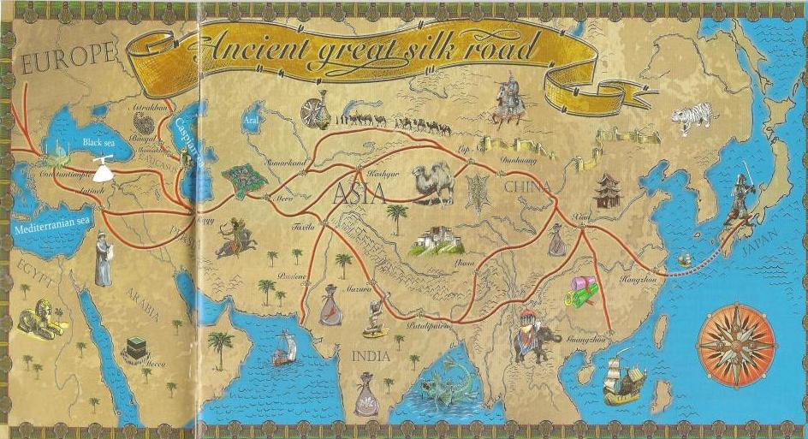

The Festival is organized by "Schoolchildren's palace" State municipal enterprise, in cooperation with International Dance Sport Association, National Dance Council of Kazakhstan, National Dance Sport Development Union supported by "Nur Otan" Party, and "Bomond" ballroom dancing ensemble.

Festival is held in May 10-11, 2014, Astana (Republic of Kazakhstan).
Event venue: "Schoolchildren's palace" State municipal enterprise,, B.Momyshuly st. 5.
The festival is held in the form of a competitive program, categories are divided by age and level of dancing.

Working languages
- working languages ​​of the Festival are Kazakh, Russian and English.

Contests on nominations are held in accordance with the Program Requirements of WDC, IDSA, NDC of Kazakhstan NDSDU.

Platform:
- parquet 320 sq.m.
Judges:
- the composition of the judiciary is formed of judges that hold the international license of WDC and other organizations.
Rewards:
- Cups, medals, diplomas and prizes.

Chairman of the Counting Committee of the Festival:
A Chairman of the Counting Commission Festival is assigned to coordinate the work of the judiciary.
The counting totals are based under the skating system.
On-line registration: From April 5 till Aril 30, 2014
SilkWayfestival.com
Registration fee:
Silk Way -12 euro (3000 tenge);
National Championship -16 euro (4000 tenge);
Eurasia open – 20 euro (5000 tenge);
IDSA Cup – 30 euro (7500 tenge).

Tickets:
Participant – 8 euro (2000 tenge) for one division;
Spectator – 1 division 1500 tenge; at the table 3000 tenge;
2 division - 1500 tenge, at the table 3000 tenge;
3 division - 3000 tenge, at the table 5000 tenge.

Organizer +7 707 4 151 151

IDSA Cup. Eurasia open
The Prize Fund composes 3500000 tenge

IDSA CUP

 | 1 | 2 | 3 | 4 | 5 | 6
16 and older. lat | 1200 euro | 800  euro | 600  euro | 400  euro | 400  euro | 400  euro
12-15 years st | 400  euro | 300  euro | 200  euro | 100  euro | 100  euro | 100  euro
12-15 years lat | 400  euro | 300  euro | 200  euro | 100  euro | 100  euro | 100  euro

Eurasia open

 | 1 | 2 | 3 | 4 | 5 | 6
16 and older. st | 1000  euro | 800  euro | 500  euro | 300  euro | 300  euro | 300  euro
14-15 years lat | 400  euro | 300  euro | 200  euro | 100  euro | 100  euro | 100  euro
12-13 years st | 300  euro | 200  euro | 200  euro | 100  euro | 100  euro | 100  euro
10-11 years lat | 300  euro | 200  euro | 200  euro | 100  euro | 100  euro | 100  euro

№ |  | Age category | Class | Dancing program | Age | Rank
May 10
1 division. Starts at 11.00 a.m

 |  | Juvenile -2 ST | E-3 | W,V,Q | 10-11 years old | Silk way
 |  | Juvenile -2 LT | D-4 | Ch, S, R, J | 10-11 years old | Silk way
 |  | Junior-1 ST | Е-3 | W,V,Q | 12-13 years old | Silk way
 |  | Junior -2 LT | Е-3 | Ch, S, J | 14-15 years old | Silk way
 |  | Junior -2 LT | D-4 | Ch, S, R, J | 14-15 years old | Silk way
 |  | Junior -2 ST | Open-5 | W,T,V,F,Q | 14-15 years old | Silk way
May 10
2 division. Starts at 3.00 p.m

 | Juvenile -1 ST |  | D-4 | W,T,V,Q | Up to 9 years old | National Championship open
 | Juvenile -2 LT |  | Open -5 | Ch, S, R,P, J | 10-11 years old | National Championship open
 | Junior -1 ST |  | Open -5 | W,T,V,F,Q | 12-13 years old | National Championship open
 | Junior -2 LT |  | Open -5 | Ch, S, R,P, J | 14-15 years old | National Championship open
 | Young ST |  | Open -5 | W,T,V,F,Q | 16-18 years old | National Championship open
 | Adult LT |  | Open -5 | Ch, S, R,P, J | 19 and older | National Championship open
May 10
3 division. Starts at 7.00 p.m

 |  | Juvenile -1 ST | Е-3 | W,V,Q | Up to 9 years old | Silk way
 |  | Junior -1 ST | Open -5 | W,T,V,F,Q | 12-13 years old | Eurasia open
 |  | Junior -1 LT | Open -5 | Ch, S, R,P, J | 12-13 years old | Silk way
 |  | Juniors LT | Open -5 | Ch, S, R,P, J | 12-15 years old | IDSA Cup
 |  | Young + Adult ST | Open -5 | W,T,V,F,Q | 16 and older | Silk way
 |  | Young + Adult LT | Open -5 | Ch, S, R,P, J | 16 and older | IDSA Cup
 |  | Formation |  |  | 10-15 years old | Silk way
May 11
1 division. Starts at 11.00 a.m

 |  | Juvenile -2 LT | Е-3 | Ch, S, J | 10-11 years old | Silk way
 |  | Juvenile -2 ST | D-4 | W,T,V,Q | 10-11 years old | Silk way
 |  | Junior -1 LT | Е-3 | Ch, S, J | 12-13 years old | Silk way
 |  | Junior -1 LT | D-4 | Ch, S, R, J | 12-13 years old | Silk way
 |  | Junior -2 ST | Е-3 | W,V,Q | 14-15 years old | Silk way
 |  | Junior -2 ST | D-4 | W,T,V,Q | 14-15 years old | Silk way
 |  | Junior -2 LT | Open -5 | Ch, S, R,P, J | 14-15 y years old | Silk way
May 11
2 division. Starts at 3.00 p.m

 | Juvenile -1 LT |  | D-4 | Ch, S, R, J | Up to 9 years | National Championship open
 | Juvenile -2 ST |  | Open -5 | W,T,V,F,Q | 10-11 years old | National Championship open
 | Junior --1 LT |  | Open -5 | Ch, S, R,P, J | 12-13 years old | National Championship open
 | Junior --2 ST |  | Open -5 | W,T,V,F,Q | 14-15 years old | National Championship open
 | Young LT |  | Open -5 | Ch, S, R,P, J | 16-18 years old | National Championship open
 | Adult ST |  | Open -5 | W,T,V,F,Q | 19 and older | National Championship open
May 11
3 division. Starts at 7.00 p.m

 |  | Juvenile -1 LT | Е-3 | Ch, S, J | Up to 9 years | Silk way
 |  | Juvenile -2 LT | Open -5 | Ch, S, R,P, J | 10-11 years old | Eurasia open
 |  | Junior -1 ST | Open -5 | W,T,V,F,Q | 12-13 years old | Silk way
 |  | Junior -2 LT | Open -5 | Ch, S, R,P, J | 14-15 years old | Eurasia open
 |  | Junior ST | Open -5 | W,T,V,F,Q | 12-15 years old | IDSA Cup
 |  | Young + Adults LT | Open -5 | Ch, S, R,P, J | 16 and older | Silk way
 |  | Young + Adults ST | Open -5 | W,T,V,F,Q | 16 and older | Eurasia open

