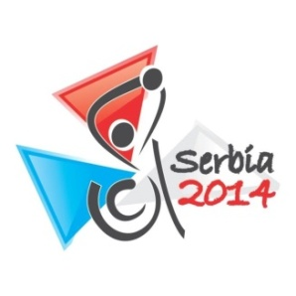
INTERNATIONAL DANCE SPORT ASSOCIATION
ASSOCIATION of DANCE PROFESSIONALS of SERBIA

2014 IPC WDS SERBIAN Open Championship

Title: SERBIAN INTERNATIONAL Pro/Am COMPETITION
SERBIAN NATIONAL PROFESSIONAL LATIN CHAMPIONSHIP - OPEN
Date: 07 - 08 JUNE 2014
Venue: Belgrade, Serbia, Hotel H oliday Inn&BELEXPO Convention Center, Španskih boraca str. 74

Nr. | Category | 7 June |  |  | 8 June
 |  | 1 part |  | 2 part | 1 part |  | 2 part
 |  | 11.00 | 14.00 | 19.30 | 11.00 | 14.00 | 19.30
1 | SERBIA INT PRO/AM (1,2,3,4,5 DANCE CHALLENGE) | SINGLE DANCE 1,2,3,4,5 | LA |  | SINGLE DANCE 1,2,3,4,5 | ST
2 | SERBIA INT PRO/AM (SCOLARSHIP) |  | LA |  |  | ST
3 | SERBIA INT VIP SHOW CASE PRO/AM |  | SHOW ST | VIP SHOW ST |  | SHOW LA | VIP SHOW ST
4 | SERBIAN NATIONAL PROFESSIONAL LATIN CHAMPIONSHIP OPEN |  |  | LA

Adjudicators: International adjudicators WDC from 7 countries.

Entry fee: Per couple per program:
Professional LA – 75 €

Tickets: VIP - 25 €

Prizes: All finalists of the competition will be rewarded with precious presents and diplomas.
Prize-holders of the competition will also be rewarded by medals and cups.

Prize money Professional LA OPEN:
1st place – 500 €; 2nd place – 300 € ; 3rd place – 250 €
4st place – 200 €; 5nd place – 150 €; 6rd place –100 €

Rules: According to WDC Regulations

Registration: For participation in competition all dance couples are admitted.

Confirmations: Confirmations are to be made exclusively via Internet and only until 20^{t} of May 2014.
After 20^{t} of May confirmations will not be accepted!!!

ORGANIZER
Association of Dance Professionals of Serbia
Zlatko Stojković
E-mail: dance.prof.serbia@gmail.com
Tel.: +381 63 229 520

