##### 

##### INTERNATIONAL DANCE SPORT ASSOCIATION

##### WORLD DANCE POLAND

##### ACADEMY OF DANCE BOLESLAW BARA

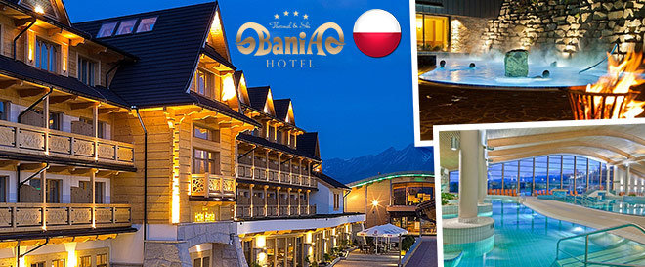

**WINTER TATRY CUP 2016**

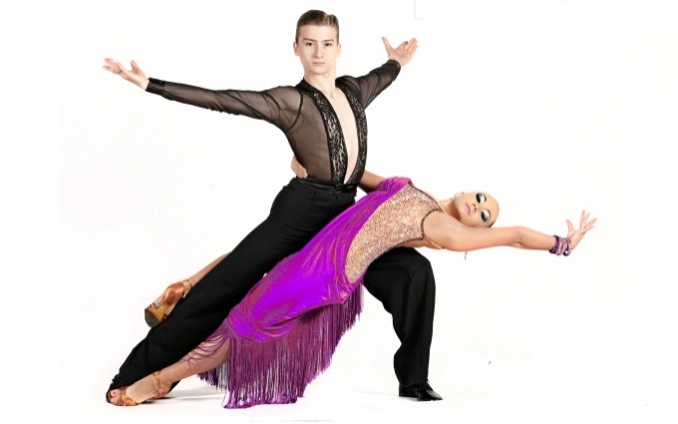

**Date: 01ST December 2016**

**Place: Poland, Nowy Targ**

**Address:** **Aleje. Tysiąclecia 74,**

**Nowy Targ, Poland, Sport Hall "Gorce"**

**Phone: +48 691 047 724**

**Adjudicators: WDC International adjudicators**

**Starting fee:**  **Per couple for one program – 20 euro**

**Rules: WDC Rules must be applied!**

**Registration: This competition is open in all age groups.**

**Registration in all age groups is made according to the**

**date of birth in passports.**

**Reservation by: boleslawbara@wp.pl - email**

**Entry: Please send your entry no later than – 30th November 2016**

**T**

**Visa invitations: boleslawbara@wp.pl**

**WINTER TATRY CUP 2016**

|  |  |  |  |  |  |
| --- | --- | --- | --- | --- | --- |
| № | CATEGORIES | 09:00- Start of competitions | 12:00 - Start of competitions | 15:00- Start of competitions | 19:00 - Start of competitions |
| 1 | Kids under 6 beginners | W,Ch,J |  |  |  |
| 2 | Kids under 6 |  | W,Ch,J |  |  |
| 3 | Kids under 8 beginners | W,Ch ,J |  |  |  |
| 4 | Kids under 8 |  | W,Ch,J |  |  |
| 5 | Solo Lady under 8 beginners | W,Ch,J |  |  |  |
| 6 | Solo Lady under 8 |  | W,Ch,J |  |  |
| 7 | Solo Lady under 13 beginners | W,Ch,J |  |  |  |
| 8 | Solo Lady under 13 |  | W,Ch ,J |  |  |
| 9 | Solo Lady under 15 beginners | W,Ch,J |  |  |  |
| 10 | Solo Lady under 15 |  | W,Ch,J |  |  |
| 11 | Solo Lady over 15 beginners, | S,Ch,J |  |  |  |
| 12 | Solo Lady over 15 |  | S,Ch,J |  |  |
| 13 | Juveniles 1 „H” under 10 |  |  | W,Q,Ch,J |  |
| 14 | Juveniles 1 „E” under 10 | 3 ST, 3 LA |  |  |  |
| 15 | Juveniles 1 „D” under 10 |  | 4 ST, 4 LA |  |  |
| 16 | Juveniles 2 „H” under 12 |  |  | W,Q,Ch,J |  |
| 17 | Juveniles 2 „E” under 12 | 3 ST, 3 LA |  |  |  |
| 18 | Juveniles 2 „D” under 12 |  |  | 4 ST, 4 LA |  |
| 19 | Juniors 1 „E” under 14 | 3 ST, 3 LA |  |  |  |
| 20 | Juniors 1 „D” under 14 |  | 4 ST, 4 LA |  |  |
| 21 | Juniors 2 „E” under 16 | 3 ST, 3 LA |  |  |  |
| 22 | Juniors 2 „D” under 16 |  |  | 4 ST, 4 LA |  |
| 23 | Youth + Adult „D” (16 and older) |  | 4 ST, 4 LA |  |  |
| 24 | Juniors 1 „C” under 14 |  |  |  | ST/LA |
| 25 | Juniors 2 „C” under 16 |  |  |  | ST/LA |
| 26 | Youth „C” under 19 |  |  | ST/LA |  |
| 27 | Youth+Adult „B” (16 and older) |  |  |  | ST/LA |
| 28 | Juveniles 1 Open under 10 |  |  | ST/LA |  |
| 29 | Juveniles 2 Open under 12 |  |  | ST/LA |  |
| **30** | **Juvenile 1 IDSA CHAMPIONSHIPS** |  |  |  | **ST LA** |
| **31** | **Juvenile 2 IDSA CHAMPIONSHIPS** |  |  |  | **ST LA** |
| **32** | **Juniors 1 IDSA CHAMPIONSHIPS** |  | ST | LA | **ST LA** |
| **33** | **Juniors 2 IDSA CHAMPIONSHIPS** |  |  |  | **ST LA** |
| **34** | **Youth 1 IDSA CHAMPIONSHIPS** |  |  |  | **ST LA** |
| **35** | **Youth 2 IDSA CHAMPIONSHIPS** |  |  |  | **ST LA** |
| **36** | **Adult IDSA CHAMPIONSHIPS** |  |  |  | **ST LA** |
| **37** | **Professional IDSA CHAMPIONSHIPS** |  |  |  | **ST LA** |
| **38** | **Professional Sequey IDSA CHAMPIONSHIPS** |  |  |  | **ST LA** |
| **39** | **Senior IDSA CHAMPIONSHIPS** |  |  |  | **ST LA** |
| 40 | Pro Am Single Dance | W,T,V,F,Q C,S,R,P,J |  |  |  |
| 41 | Pro Am 2 Dance Challenge |  | W,T,C,R |  |  |
| 42 | Pro Am 3 Dance Challenge |  |  | W,T,Q,C,S,R |  |
| 43 | Pro Am Scholarship |  |  |  | ST/LA |

|  |  |
| --- | --- |
| **ORGANIZERS:**  **INTERNATIONAL DANCE SPORT ASSOCIATION**  **SVYATOSLAV VLOKH, IDSA PRESIDENT**  **E-MAIL:** [vloh@voliacable.com](mailto:vloh@voliacable.com);  [www.udsa.com.ua](http://www.udsa.com.ua), [www.idsa.com.ua](http://www.idsa.com.ua)  **MOBILE:+380674427534** | ORGANIZERS:WORLD DANCE POLANDAKADEMIA TAŃCA **BOLESŁAW BARA,**  **E-MAILS:** [boleslawbara@wp.pl](mailto:boleslawbara@wp.pl)  **MOBILE: +48 691 047 724** |