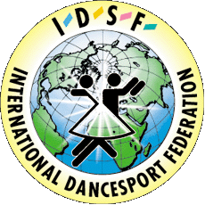 | INTERNATIONAL DANCE SPORT FEDERATION  UKRAINIAN DANCE SPORT ASSOCIATION  DANCE SPORT CLUB GRACIA

“UZHGOROD OPEN – 2003”

IDSF OPEN STANDARD
IDSF OPEN LATIN
Title: International Dancesport Competition “Uzhgorod Open – 2003”
Date: 1 May 2003
Place: Spor Complex Gimnazium (44, 8 Bereznya str.), Uzhgorod, Ukraine.
Categories:

Categories | 1 May 2003
Categories | 10:00 | 17:00
Juvenalies I+II | St | La
Juniors I | La | St
Juniors II | La | St
Youth | St | La
Adults, IDSF Open | St | La

Judges: International Judges from different Nationalities:
Dress: IDSF rules must be applied!
Starting fee: Juvenalies, Juniors, - USD 10; Youth – USD 15; Adults – USD 20
Entry tickets: USD 2
Prizes: For all finalists – beautiful prizes!
Hotel price: From USD 3-20 per one person/night
Entry: Please send your entry no later then 20.04.2003

 | DanceSport Club “GRACIA”  Ms. Oleksandra & Volodymyr Myshko  6/7, Grushevskogo str. Uzhgorod  Ukraine-88000  Phone/Fax: ++380 3122 22 22 8  Mobil: ++380 067 722 06 12  ++380 050 560 45 53  +421 0908 25 68 98
  Ukrainian DanceSport Association
  Dr. Sviatoslav T. Wloch, UDSA President
  7/13, Saksaganskoho str., Kyiv
  Ukraine-01033
  Phone/fax: ++380 44 220 02 51
  E-mail: udsa@gu.kiev.ua

