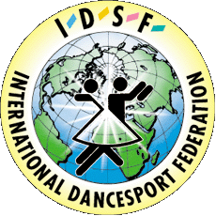 | International DanceSport Federation  Ukrainian DanceSport Federation  DanceSport Club “PROMIN”
Status – 18.03.2003

CHERNIVTSI OPEN 2003

IDSF Open ST & LA

Title: IV International Open DanceSport Competitions
CHERNIVTSI OPEN 2003
Date: 5 October 2003
Place: “Junist Bukovini” Cyervonoarmijska str. 5,
Chernivtsi, Ukraine.

CATEGORIES | 10.00 | 17.00
Juveneles I | LA | ST
Juveneles II | ST | LA
Juniors I | LA | ST
Juniors II | ST | LA
Youts | ST | LA
Adults – IDSF Open | ST | LA
UDSA Formation Cup | ST

Judges: IDSF and UDSA Licensed Adjudicators
Dress: IDSF Rules must be applied!
Starting fee: Per couple for one program:
Juveniles, Juniors I 10 USD;
Juniors II, Youth 15 USD;
Adults 20 USD.
Hotel: 4-20 USD
Prizes: For all Finalists – beautiful prizes.
Entry: Please, send your entry no later than 25th September to:

Organizer: Zoya & Vladimir Khomitskyy
253\ 38 Russkaya str. , Chernivtsi Ukraine
Phone\ fax: **380 (3722) 60989., 25484
Phone: **380 (3722) 25267, 23036
E-mail: promin@ chv.ukrpack.net
www. promindance.org.ua

