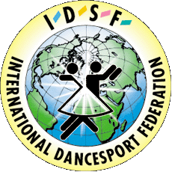 | INTERNATIONAL DANCESPORT FEDERATION  UKRAINIAN DANCESPORT ASSOCIATION  DANCE SPORT CLUB “HARMONY”

Status – 22.03.2003

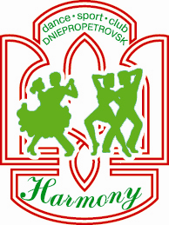
STANISLAV SHKLYAR’S CUP –2003
UDSA Grand Prix’s FORTH event 2003

IDSF OPEN STANDARD & LATIN

UKRAINIAN ADULTS TEN DANCE CHAMPIONSHIP 2004

UKRAINIAN YOUTH CHAMPIONSHIP STANDARD & LATIN 2004
Title: II International Open DanceSport Competitions “STANISLAV SHKLYAR’S CUP–2003”
Date: 12–14 December 2003
Place: Sports Palace “METEOR”, ul. Bol’shevistskaya 1, Dnepropetrovsk, Ukraine

Categories: | Friday, 12 December |  |  | Saturday, 13 December |  |  | Sunday, 14 December
Categories: | 9³⁰ | 14³⁰ | 19³⁰ | 9³⁰ | 14³⁰ | 19³⁰ | 9³⁰ | 14³⁰ | 19³⁰
Juveniles 1 “E” | 6 D
Juveniles 2 “E” | 6 D
Juniors 1 “E” | 6 D
Juveniles 2 “D” |  | ST+LA
Juniors 1 “C” | ST | LAT
Juniors 2 “C” |  | ST | LAT
Juniors 1+2 “D” | ST | LAT
Youth (16-21) “C” |  | LAT | ST
IDSF Open Adults |  |  |  |  |  | ST |  |  | LAT
IDSF Open Senior |  |  |  |  |  | ST |  |  | LAT
IDSF Open Youth |  |  |  |  | LAT | ½ LAT |  | ST | ½ ST
IDSF Open Juniors 2 |  |  |  |  | ST |  |  | LAT
IDSF Open Juniors 1 |  |  |  | LAT |  |  | ST
IDSF Open Juveniles 2 |  |  |  | ST |  |  | LAT
IDSF Open Juveniles 1 |  |  |  | ST |  |  | LAT
UDSA 10 dance Championship Adults |  |  | ST+LA
UDSA Championship Youth |  | ST | LAT
Judges: 11 International Judges from different Nationalities in each category
Dress: IDSF Rules must be applied
Starting fee: Per couple for one program:
Juveniles, Juniors, Youth & Senior – USD 15; Adult – USD 20;
Prize money: Adult: 1st place – USD 300, 2nd place – USD 200, 3rd place – USD 100
Hotel: Per person per night from USD 5 to USD 50
Entry: Please, send your entry no later than 20th November 2003 to:

Ukrainian Dance Sport Association  Mr. Dr. Sviatoslav T. Wloch, UDSA President  7/13, Saksaganskoho str., Kyiv-01033, Ukraine  Phone: +38 044 239 23 35  Fax: +38 044 220 02 51  E-mail: udsa@gu.kiev.ua  Web-Site: www.udsa.com.ua | Dance Sport Club “HARMONY”  Mr. Oleg A. Petrovs’kyy, DSC “Harmony” President  12, V.Dubinin str., Dnepropetrovsk, 49050, Ukraine  Phone: +38 0562 36 64 65  Fax: +38 056 776 73 76  E-mail: harmony@a-teleport.com  E-mail: kybok@ukr.net  Web-Site: www.dance.dp.ua

