Status – 02.02.2004
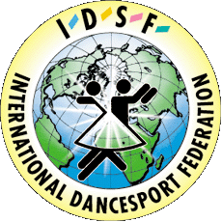
INTERNATIONAL DANCE SPORT FEDERATION
UKRAINIAN DANCE SPORT ASSOCIATION
DANCESPORT CLUB “SPORT DANCE”
PARADE OF HOPES 2004
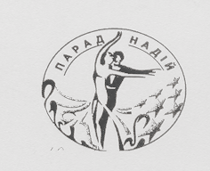
KYIV OPEN Championship
kyiv Major’s Cup
IDSF OPEN STANDARD
idSF OPEN LATIN
UDSA Grand prix’s first event 2004
Title: XIV –th International DanceSport Competition “Parade of Hopes - 2004”
Date: 27-28 March 2004
Place: Sport Complex “Merydian”, Kyiv, Ukraine (Geroyiv Sevastopolya str. 11-v)

Categories | 27 March 2004 |  |  | 28 March 2004
Categories | 09:30 | 13:30 | 18:00 | 09:30 | 13:30 | 18:00
UDSA Championship Youth | 10 dance |  |  | St
UDSA Championship Adults | St |  |  | La
UDSA Championship Senior |  | St |  | La
UDSA Championship Formation |  |  |  |  | La
Juveniles 1 “E” | La |  |  | St
Juveniles 2 “E” |  | La |  |  | St
Junior 1 “E” |  | La |  |  | St
Juniors 1 “D” |  | St |  | La
Juniors 2 “E+D” | La |  |  | St
IDSF Open Juveniles 1 | St |  |  | La
IDSF Open Juveniles 2 |  | St | Final |  | La | Final
IDSF Open Juniors 1 |  | La | Final |  | St | Final
IDSF Open Juniors 2 |  |  | La |  |  | St
IDSF Open Youth |  | St |  |  | La
IDSF Open La |  |  |  |  |  | La
IDSF Open St |  |  | St

Judges: International Judges from different Nationalities
Dress: IDSF Rules must be applied!
Starting fee: Per couple for one program:
Juveniles, Juniors, Seniors, Youth – Euro 15; Adults – Euro 20
Entry tickets: Euro 2 -4
Prizes: For all finalists – very beautiful prizes
Hotel price: from Euro 5 to Euro 15 per one person/night. Contact: +380 44 463 01 70
Entry: Please, send your entry no later than 01 March, 2004 to:
ORGANIZER  Mrs. Valentyna Fedorchuk  Rad. Ukrainy 30, app. 56, Kyiv, Ukraine-04215  Phone/fax: +380 44 463 01 70, +380 44 424 22 45  E-mail: sportdans@ukr.net | Ukrainian Dance Sport Association  Dr. Svyatoslav T. Wloch, UDSA President  7/13, Saksahanskoho str., Kyiv, Ukraine-01033  Phone/fax: +380 44 220 02 51  E-mail: udsa@gu.kiev.ua  www.udsa.com.ua

