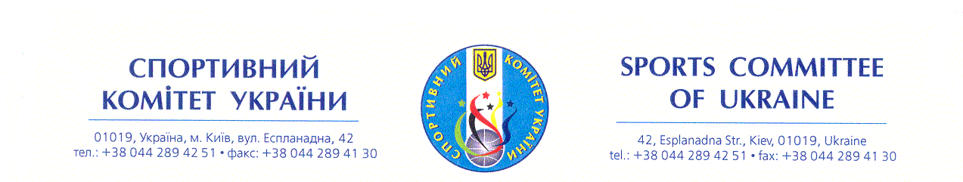

19th of May 2007 Kyiv, Ukraine

P R E S S R E L E A S E 001 / 07

On 18th of May 2007 in the premises of the meeting hall of hotel “Premier Palace” took place the Constituting Conference of European Sport Committee. At the Conference were present representatives from 10 European countries who represent organizations on non-Olympic kinds of sports in their respective countries, i.e. from Bulgaria, Georgia, Greece, Israel, Lithuania, Moldova , Poland, Romania, Serbia, and of course from Ukraine. Also at the Conference were present minister of Ukraine on affairs of family, youth and sports – Viktor Korzh, vice-minister of finance of Ukraine – Vadym Kopylov, people’s deputy of Ukraine, Head of Verkhovna Rada Committee on economical politics – Volodymyr Zaplatynsky, vice-minister of Ukraine on affairs of family, youth and sports – Viktor Khrystoyev, Head of department on non-Olympic kinds of sports, First Vice-president of Sport Committee of Ukraine – Oleksandr Artyemyev, General Secretary of Sport Committee of Ukraine – Anatoliy Bilov. And also guests from Poland: advisor to minister of sports of Poland, member of NOC of Poland – Mieczyslaw Bigoszewski, General Secretary of European Karate Federation - Andrzej Drewniak; and guests from Lithuania: administration director of city Siauliai - Rimundas Domarkas, Head of the office of sports - Kestutis Petraitis.
Delegates have approved the Statute of newly created European Sport Committee, and in the nearest future this European structure will be registered in the Ministry of Justice of Ukraine.
Also at the Conference delegates elected Executive Committee in structure: President – Vadym Kopylov (Ukraine), First Vice-president – Gintautas Vileita (Lithuania), Vice-president on financial questions – Svyatoslav Vlokh (Ukraine), General Secretary – Oleksandr Artyemyev (Ukraine), Second General Secretary – Maryna Gordiienko (Ukraine), and also Members of Executive Committee: Zlatko Stojkovich (Serbia), Marek Sienkiewicz (Poland), Sofia Pavlidi (Greece), Illia Mihov (Bulgaria), Anatoly Trilisky (Israel). To the structure of Revision Commission entered: Boris Volosatyy (Moldova, Head of Revision Commission), Murad Enukidze (Georgia), Maxim Condratiev (Romania).
At the Constituting Conference was considered application from city of Siauliai, Lithuania about hosting of The Second European Sport Games in 2011. Delegates supported this application unanimously, and made decision to grant the right to host and conduct The Second European Sport Games in city of Siauliai, Lithuania in 2011. Our sincere congratulations to Siauliai!
We all understand the importance of this event, and are very grateful to everybody for support in its conduction and organization, to all those who put incredible efforts for creation of such important European structure as European Sport Committee which unified kinds of sports which are not included into the program of Olympic Games.
We express our gratitude to Sport Committee of Ukraine which performed as initiator and organizer of this event. And we look forward to The First European Sport Games which will take place in July this year in city of Kyiv!

