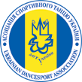
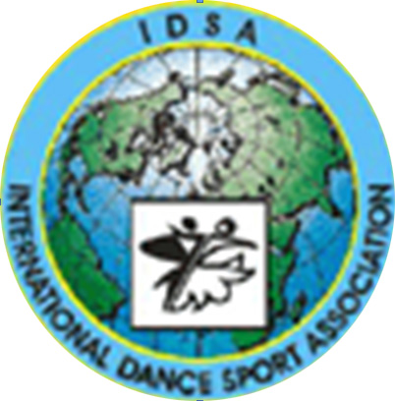
The ministry of physical culture and sports of Ukraine
International dance sport association
City executive administration of Yuzhny
Dance club “YUZHNY”

Yuzhny Major Cup 2010
25-26 September
IDSA World Championships Latin and Standard
Place of carrying out: Yuzhny, Primorskaya str. 1, Sport palace «PORTOVIK»
Yuzhny Major Cup 2010
GROUP | 25 September |  |  | 26 September
GROUP | 09.30 | 14.00 | 19.00 | 09.30 | 14.00 | 19.00
Baby |  |  | W, Ch, J
Solo juveniles I |  |  |  | W, Ch, J
Solo juveniles II |  |  |  | W,Q,Ch,J
Solo juniors I |  |  |  | Ch, S, J
Solo juniors II |  |  |  | Ch,S,R,J
Super Baby (under 6) |  |  |  | W, Ch,
Juveniles I beginners |  | W, Ch, J
Juveniles I E | La | St
Juveniles I D | La |  |  | St
Juveniles II beginners | W,Q,Ch,J
Juveniles II E | St | La
Juveniles II D | La |  |  | St
Juniors I beginners |  | W,Q,CH,J
Juniors I E | La | St
Juniors I D | St |  |  | La
Juniors I C |  | St |  |  | La
Juniors II E |  |  |  | St | La
Juniors II D | St |  |  | La
Juniors II C | St |  |  | La
Hobby (under 18) |  | La |  |  | St
Hobby (after 18) |  | La |  |  | St
Juveniles I (under 10) major cup |  | St |  |  | La
Juveniles II (under 12) major cup |  | St |  |  | La
Juniors I (under 14) major cup |  |  | St |  | La
Juniors II (under 16) major cup |  |  | La |  |  | St
Youth (under 19) major cup |  |  | La
Youth (under 21) major cup |  |  | St
Adult major cup |  |  | St
Waltz and Samba major cup |  |  | W |  |  | S
IDSA World Championships Youth (under 19) |  |  |  |  |  | St
IDSA World Championships Youth (under 21) |  |  |  |  |  | La
IDSA World Championships Adult |  |  |  |  |  | La
PRO-AM |  |  | SHOW
PRO-AM |  | La |  |  | St
Judges: Sniguole Wood (England), Graham Oswick (England), Hannes Emrich (England), Сергей Рюпин (Россия), Jerry Abrate (Italy), Владислав Бородинов (Россия), Katerina Arzenton (Italy) and all judges from different Associations
Dress: IDSA Rules must be applied!
Starting fee: Per couple for one program:
W and S, Girls- 15Є. Beginners, Е, D,C class – 25Є. Juveniles, Juniors, Hobby—25Є. Youth, Adult –30Є.
Prize money for IDSA World Championship Latin:
Adult – places: 1st-500$, 2^{nd-}300$, 3rd -200$
For other finalists beautiful prizes, diplomas, medals and cups.
Hotel price: from 10 Є to 300 Є per one person/night. Please, send your entry no later than 15 September2010.
Entry: Please, send your entry no later than 17 September 2010. dinamoilichevsk@ukr.net
Tickets: from 7Є to 10Є. For a reserve of tables call to organizers.

В Н И М А Н И Е ! ! !

С 22 по 24 сентября в г. Южный
проводятся индивидуальные уроки
с ТОП - тренерами:

Sniguole Wood (England) Standard
Graham Oswick (England) Latin
Hannes Emrich (England) Latin
Сергей Рюпин (Россия) Latin
Jerry Abrate (Italy) Latin
Владислав Бородинов (Россия) Latin
Katerina Arzenton (Italy) Standard

Бронирование уроков через организаторов!!!

ТЕЛ.: 8 (048) 735 85 38

Dance Sport Club “DUSSH №1”  Ms. Yana Surmay  151\1 163 str.Dobrovolskogo, Odessa  Ukraine  Phone: +380 67 749 34 69  E-mail: tanci_studiya@mail.ru | Dance Sport Club ”Yuzhny”  Mr. Victor Paliy  14 Solyana str., Odessa  Ukraine  Phone: +380 67 712 74 76  Fax:+ 380 48 2678735, mob. + 380 48735 85 38  E-mail: dinamoilichevsk@ukr.net

