
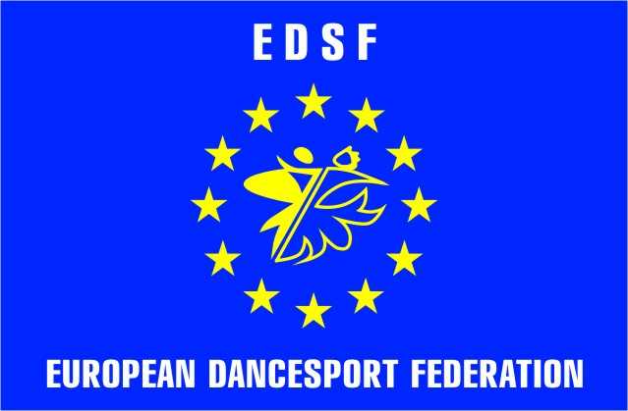
INTERNATIONAL DANCE SPORT ASSOCIATION
EUROPEAN DANCE SPORT FEDERATION
UKRAINIAN DANCE SPORT ASSOCIATION
UDSA BRANCH IN CHERNIVTSI REGION

BUKOVYNA CUP 2011

EDSF EUROPEAN CUP LATIN JUNIOR 2- 2011

Number of group | AGE GROUP: | Saturday,  08th October |  |  | Sunday,  09th October
Number of group | AGE GROUP: | 10.00 | 14.00 | 19.00 | 10.00 | 14.00 | 19.00
 | SENIOR (over 35) |  |  |  |  | ST | LA
 | adult (16 and older) |  |  | ST |  |  | LA
 | YOUTH 2 (under 21) |  | ST |  |  | LA
 | YOUTH 1 (under 19) |  |  | ST |  |  | LA
 | JUNIOR 2 (under 16) |  |  | LA |  | ST
 | JUNIOR 1 (under 14) |  | ST |  |  |  | LA
 | JUVENILE 2 (under 12) |  | LA |  |  | ST
 | JUVENILE 1 (under 10) |  |  | LA |  |  | ST
 | BABY (under 6) |  |  |  | 2 dance
 | BABY (under 8) |  |  |  | 2 dance
 | SCHOOL 1 (under 8) | 3 dance
 | SCHOOL 2 (under 10 ) | 3 dance
 | SCHOOL 3 (under 12) | 3 dance
 | CHILDREN “h” ( under 8) |  | W,Q,Ch,J
 | JUVENILE 1 «H» (under 10) |  | W,Q,Ch,J
 | JUVENILE 2 “H” (under 12) beginners) |  | W,Q,Ch,J
 | JuNIOR 1 “H” (under 14) |  | W,Q,Ch,J
 | HOBBY “H” (over 14) |  | W,Q,Ch,J
 | Juvenile 1 “e” (under 10) | ST (3 d.) | LA (3 d.)
 | juvenile 2 “E” (under 12) | ST (3 d.) | LA (3 d.)
 | junior 1 “e” (under 14) | ST (3 d.) | LA (3 d.)
 | junior 2 “e” (under 16) | ST (3 d.) | LA (3 d.)
 | juvenile 1+2 “D” | ST 4 dance |  | LA 4 dance
 | junior 1 “D” | ST 4 dance |  | LA 4 dance
 | junior 2 “D” | ST 4 dance |  | LA 4 dance
 | Youth + adult hobby |  |  |  | ST 4 dance | LA 4 dance
 | juvenile 1+2 C class |  |  |  | ST 4 dance | LA 4 dance
 | junior 1 C class under 14 |  |  |  | ST 4 dance | LA 4 dance
 | junior 2 c class under 16 |  |  |  | ST 4 dance | LA 4 dance
 | youth c class |  |  |  | ST 4 dance | LA 4 dance
 | Sollo (under 8) |  | 2 dance
 | PRO-AM

Title: «EDSF EUROPEAN CUP LATIN JUNIOR 2- 2011»

Date: 08-09th October 2011
Place: Shopping and entertaining center “Panorama”, Khotynska str. 43, C Chernivtsi, Ukraine
Adjudicators: 11 WDC International Adjudicators
Starting fee: Per person for one program: Rating - 150 UAH, “School” – 80 UAH, “ b beginners,“E”, hobby, “D” , “C”- 100 UAH

Rules: WDC Rules must be applied!
Registration: All dance couples are allowed to take part in the open competition in all age groups. Registration in all age groups is made according to the date of birth in passports.
Hotel: Reservation by: vladimir_chernyshevskyy@mail.ru
Entry: Please send your entry no later than 01th October, 2011
Visa invitations: vloh@voliacable.com

Organizers:  European Dance Sport Federation  Svyatoslav Vlokh, EDSF President  E-mails: udsa@gu.kiev.ua; vloh@voliacable.com;  sportcom-ukraine@ukr.net  Tel/fax: +380442890251, Tel.: +380442392335  Mobile:+380674427534 | Organizers:  UDSA Branch in Chernivtsi region  Volodymyr Chernyshevskyy, President  E-mail: vladimir_chernyshevskyy@mail.ru  Mobile: +380505141382  +380505128572

