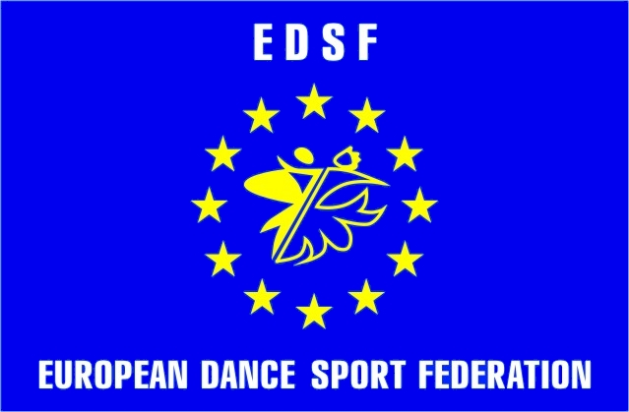 | Ministry of Ukraine for Family, Youth and Sport  European Dance Sport Federation  Ukrainian Dance Sport Association  Lviv Region Center of UDSA  Sport Dance Clubs “Aelita” & “Wikadance” | 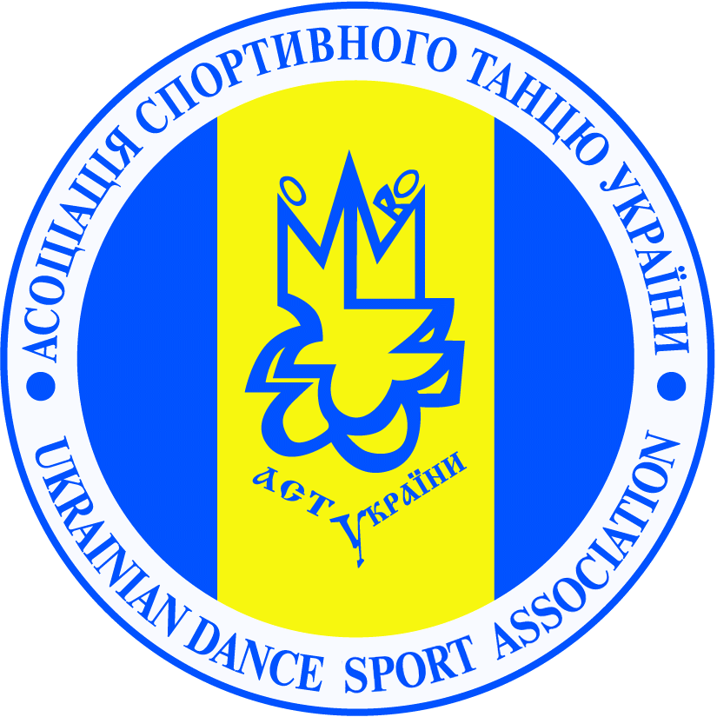

“EDSF OPEN CUP – 2012”

Title: Open dancesport competitions “EDSF OPEN CUP – 2012”
Date: 11th of February 2012
Place: Lviv, Ukraine
Sport hall “Graciya”, Trade center “Pivdennyy”, Shchyretska str. 36
№ | CATEGORIES | 9:00– REGISTR.  10:00- START OF COMPETITIONS | 13:00– REGISTR.  13:30- START OF COMPETITIONS | 17:30– REGISTR.  18:00- START OF COMPETITIONS
1 | Juveniles 1 “E” (under 10) | 3 ST, 3 LA
2 | Juveniles 2 “E” (under 12) | 3 ST, 3 LA
3 | Juniors 1 “E” (under 14) | 3 ST, 3 LA
4 | Juniors 2 “E” (under 16) | 3 ST, 3 LA
5 | Youth +Adult “E” (16 and older) | 3 ST, 3 LA
6 | Juveniles “D” (under 12) |  | 4 ST, 4 LA
7 | Juniors 1 “D” (under 14) |  |  | 4 ST, 4 LA
8 | Juniors 2 “D” (under 16) |  | 4 ST, 4 LA
9 | Youth +Adult “D” (16 and older) |  | 4 ST, 4 LA
10 | Juniors 1 “С” (under 14) |  | ST, LA
11 | Juniors 2 “С” (under 16) |  | ST, LA
12 | Youth “С” (under 19.) |  | ST, LA
13 | Youth +Adult “B” (16 and older) |  | ST, LA
14 | Juveniles Open (under 12) |  |  | ST, LA
15 | Juniors 1 Open (under 14) |  |  | ST, LA
16 | Juniors 2 Open (under 16) |  |  | ST, LA
17 | Youth 1 Open (under 19) |  |  | ST, LA
18 | Youth 2 Open (under 21) |  | ST, LA
19 | Adult Open (21 and older) |  |  | ST, LA
20 | Seniors Open (over 35) |  |  | ST, LA

Entry fee: Per person per program:
Juveniles , Juniors, Youth, Adults Open – 120 UAH.;
Classification competitions: «E, «D»- 80 UAH. «C», «B» - 100 UAH.;
Tickets: 50 UAH.
Prizes: All finalists of the competition will be rewarded by diplomas.
Prize-holders of the competition will be rewarded by diplomas, medals and cups.

Rules: According to WDC and UDSA Regulations.
Confirmations: Confirmations are to be made by Internet or fax until 7th of February.
Adjudicators: Invited WDC adjudicators.

Organizators:
 | Maksym Ilyinov  E-mail: wikadance@mail.ru  Mob.: +38 (097) 380 74 43  +38 (050) 674 44 44
  Yuriy Prochko
  E-mail:yuriyprochko@yahoo.com
  Mob.: +38 (067) 670 28 25
  Tel./fax.: +38 (032) 293 74 11

УВАГА!!!
У п’ятницю 10 лютого 2012 року вперше у Львові будуть проводитись індивідуальні та групові заняття з
Лукою Тонелло та Катериною Баруліною (Італія).
За детальною інформацією просимо звертатись до організаторів змагань.

