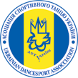
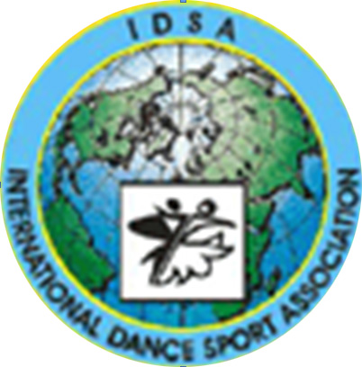
The ministry of education and sports of Ukraine
International dance sport association
City executive administration of Yuzhny
Dance club “YUZHNY”

Yuzhny Major Cup 2012
3-4 November
Closed National Championships of Ukraine between the teams of regions
Place of carrying out: Yuzhny, Primorskaya str. 1, Sport palace «PORTOVIK»
Yuzhny Major Cup 2012
GROUP | 3 November |  |  | 4 November
GROUP | 09.00 | 14.00 | 19.00 | 09.00 | 14.00 | 19.00
Baby (6-7) |  |  | W, Ch, J
Solo juveniles I |  |  |  | W, Ch, J
Solo juveniles II |  |  |  | W,Q,Ch,J
Solo juniors I |  |  |  | Ch, S, J
Solo juniors II |  |  |  | Ch,S,R,J
Super Baby (under 6) |  |  |  | W, Ch,
Juveniles I beginners |  |  |  |  | W, Ch, J
Juveniles I E | 3,La | 3,St
Juveniles I D | 4,La |  |  | 4,St
Juveniles II beginners |  |  |  | W,Q,Ch,J
Juveniles II E | 3,St | 3,La
Juveniles II D | 4,La |  |  | 4,St
Juniors I beginners |  | W,Q,CH,J
Juniors I E | 3,La | 3,St
Juniors I D | 4,St |  |  | 4,La
Juniors I C |  | 5,St |  |  | 5,La
Juniors II E |  |  |  | 3,St | 3,La
Juniors II D | 4,St |  |  | 4,La
Juniors II C | 5,St |  |  | 5,La
Hobby (under 18) |  | 4,La |  |  | 4,St
Hobby (after 18) |  | 4,La |  |  | 4,St
Juveniles I (under 10) major cup |  | St |  |  | La
Juveniles II (under 12) major cup |  | St |  |  | La
Juniors I (under 14) major cup |  |  | St |  |  | La
Juniors II (under 16) major cup |  |  | St |  |  | La
Youth (under 19) major cup |  |  | La |  |  | St
Youth (under 21) major cup |  |  | La |  |  | St
Adult major cup |  |  | St |  |  | La
Waltz and Samba major cup |  |  | W |  |  | S
National Championship Juveniles I (under 10) |  |  | St |  |  | La
National Championship Juveniles II (under 12) |  |  | St |  |  | La
National Championship Juniors I (under 14) |  | St |  |  | La
National Championship Juniors II (under 16) |  | St |  |  | La
National Championship Youth (under 19) |  | La |  |  | St
National Championship Youth (under 21) |  | La |  |  | St
National Championship Adult |  | St |  |  | La
National Championship Seniors |  |  | St |  |  | La
PRO-AM |  |  | SHOW
PRO-AM |  | La |  |  | St
Judges: Snieguole Wood (England), Alison Fulham (England), Hannes Emrich (England), Rene Barsi (France), Jerry Abrate (Italy), Denise Abrate (Italy), Luca Tonello (Italy), Денис Донской (Россия), Lev Pyankov (Russia), Anatoly Trilisky (Israel), Максим Кондратьев (Румыния), Ирина Кондратьева (Молдова) and all judges from different Associations
Dress: WDC, IDSA Rules must be applied!
Starting fee: Per person for one program:
W and S, Solo, Beginners, Е, D,C class – 100grn
Per couple for one program: Juveniles, Juniors, Hobby—25Є. Youth, Adult –35Є.
For other finalists diplomas, medals and cups.
Flats reserve: +380509546715; +380936095311 Liliya.
Entry: Please, send your entry no later than 25 October 2012. Online: http://reg.tancmir.com/;
All information: udsa.com.ua dinamoilichevsk@ukr.net
Tickets: from 70-100grn. For a reserve of tables call to organizers +380935676315 Anna

В Н И М А Н И Е ! ! !
С 31.10 по 2.11 в г.Южный
проводятся индивидуальные уроки
с ТОП - тренерами:
Snieguole Wood (England) Ballrom
Luca Tonello (Italy) Ballroom
Marek Kosaty, Paulina Glazik(Poland) Ballroom
Alison Fulham (England) Ballroom, Latin
Jerry Abrate (Italy) Latin
Hannes Emrich (England) Latin
Rene Barsi (France) Latin
Dmytro Vlokh(Ukraine) Latin
Бронирование уроков через организаторов!!!

ТЕЛ.: (048) 735 85 38

Dance Sport Club “DUSSH №1”  Ms. Yana Surmay  151\1 163 str.Dobrovolskogo, Odessa  Ukraine  Phone: +380 67 749 34 69  E-mail: tanci_studiya@mail.ru | Dance Sport Club ”Yuzhny”  Mr. Victor Paliy  14 Solyana str., Odessa  Ukraine  Phone: +380 67 712 74 76  Fax:+ 380 48 2678735, mob. + 380 48735 85 38  E-mail: dinamoilichevsk@ukr.net | KST "MECHTA", Slesarenko Snizhanna, Yuzhny, ui. Novobilyarskaya 28/2 kv. 99  0932336927  tagmil@rambler.ru
www.odessa-dance.com
Online registration: http://reg.tancmir.com/

