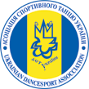
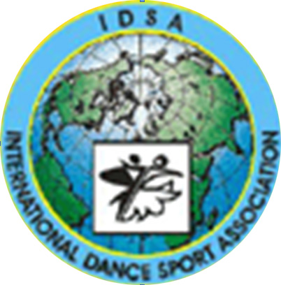
The ministry of education and sports of Ukraine
International dance sport association
National University «Odessa Law Academy»
Children and Youth Sports School №1

Odessa Dance Festival 2013
2-3 November
Closed National Championships of Ukraine between the teams of regions
Place of carrying out: Odessa, Novoberegovaya str. 92, Sport palace «Odessa Law Academy»
Odessa Dance Festival 2013
GROUP | 2 November |  |  | 3 November
GROUP | 09.00 | 14.00 | 19.00 | 09.00 | 14.00 | 19.00
Super Baby (3-5) |  |  |  | W, Ch
Baby (6-7) |  |  | W, Ch, J
Solo Super Baby (3-5) |  |  |  | W, Ch
Solo Baby (6-7) |  |  |  | W, Ch
Solo juveniles I |  |  |  | W, Ch, J
Solo juveniles II |  |  |  | W,Q,Ch,J
Solo juniors I |  |  |  | Ch, S, J
Solo juniors II |  |  |  | Ch,S,R,J
Juveniles I beginners |  |  |  |  | W, Ch
Juveniles I beginners |  |  |  |  | W, Ch, J
Juveniles I beginners |  |  |  |  | W,Q,Ch,J
Juveniles I E | 3,La | 3,St
Juveniles I D | 4,La |  |  | 4,St
Juveniles II beginners |  |  |  | W,Q,Ch,J
Juveniles II E | 3,St | 3,La
Juveniles II D | 4,La |  |  | 4,St
Juniors I beginners |  | W,Q,CH,J
Juniors I E | 3,La | 3,St
Juniors I D | 4,St |  |  | 4,La
Juniors I C |  | 5,St |  |  | 5,La
Juniors II E |  |  |  | 3,St | 3,La
Juniors II D | 4,St |  |  | 4,La
Juniors II C | 5,St |  |  | 5,La
Hobby (under 18) |  | 4,La |  |  | 4,St
Hobby (after 18) |  | 4,La |  |  | 4,St
Juveniles I (under 10) Odessa Law Academy cup |  | St |  |  | La
Juveniles II (under 12) Odessa Law Academy cup |  | St |  |  | La
Juniors I (under 14) Odessa Law Academy cup |  |  | La |  |  | St
Juniors II (under 16) Odessa Law Academy cup |  |  | La |  |  | St
Youth (under 19) Odessa Law Academy cup |  |  | St |  |  | La
Youth (under 21) Odessa Law Academy cup |  |  | St |  |  | La
Adult Odessa Law Academy cup |  |  | St |  |  | La
PROFESSIONALS Odessa Law Academy cup |  |  | La |  |  | ST
National Championship Juveniles I (under 10) |  |  | St |  |  | La
National Championship Juveniles II (under 12) |  |  | St |  |  | La
National Championship Juniors I (under 14) |  | La |  |  | St
National Championship Juniors II (under 16) |  | La |  |  | St
National Championship Youth (under 19) |  | St |  |  | La
National Championship Youth (under 21) |  | St |  |  | La
National Championship Adult |  | St |  |  | La
National Championship Seniors |  |  | St |  |  | La
National Championship PROFESSIONALS |  | 10d | La |  |  | St
PRO-AM |  |  | SHOW
PRO-AM |  | La |  |  | St
Waltz and Samba Odessa Law Academy cup |  | La | W |  | St | S
Judges: Snieguole Wood (England), Michael Stylianos (England), Rene Barsi (France), Jerry Abrate (Italy), Luca Tonello (Italy), Ekaterina Borulina (Russia), Ivan Krylov (Russia),Pavel Troshychev (Russia), Максим Кондратьев (Румыния), Ирина Кондратьева (Молдова) and all judges from different Associations
Dress: WDC, IDSA Rules must be applied!
Starting fee: Per person for one program:
W and S, Solo, Beginners, Е, D,C class – 100grn
Per couple for one program: Juveniles, Juniors, Hobby—25Є. Youth, Adult –35Є.
For other finalists diplomas, medals and cups.
Entry: Please, send your entry no later than 25 October 2013. odessadanceua@mail.ru dinamoilichevsk@ukr.net
Tickets: from 70-100grn. For a reserve of tables call to organizers +380931415144 Olga

В Н И М А Н И Е ! ! !
С 30.10 по 1.11 в г.Одесса
проводятся индивидуальные и групповые уроки
с ТОП - тренерами:
Snieguole Wood (England) Ballrom
Luca Tonello (Italy) Ballroom
Ekaterina Borulina (Russia) Ballroom
Alison Fulham (England) Ballroom, Latin
Michael Stylianos (England) Latin
Jerry Abrate (Italy) Latin
Rene Barsi (France) Latin
Dmytro Vlokh(Ukraine) Latin
Бронирование уроков через организаторов!!!

ТЕЛ.: 8 (048) 735 85 38

Dance Sport Club “DUSSH №1”  Ms. Yana Surmay  151\1 163 str.Dobrovolskogo, Odessa  Ukraine  Phone: +380 67 749 34 69  E-mail: tanci_studiya@mail.ru | Dance Sport Club “DUSSH №1”  Mr. Victor Paliy  14 Solyana str., Odessa  Ukraine  Phone: +380 67 712 74 76  Fax:+ 380 48 2678735, mob. + 380 48735 85 38  E-mail: dinamoilichevsk@ukr.net

