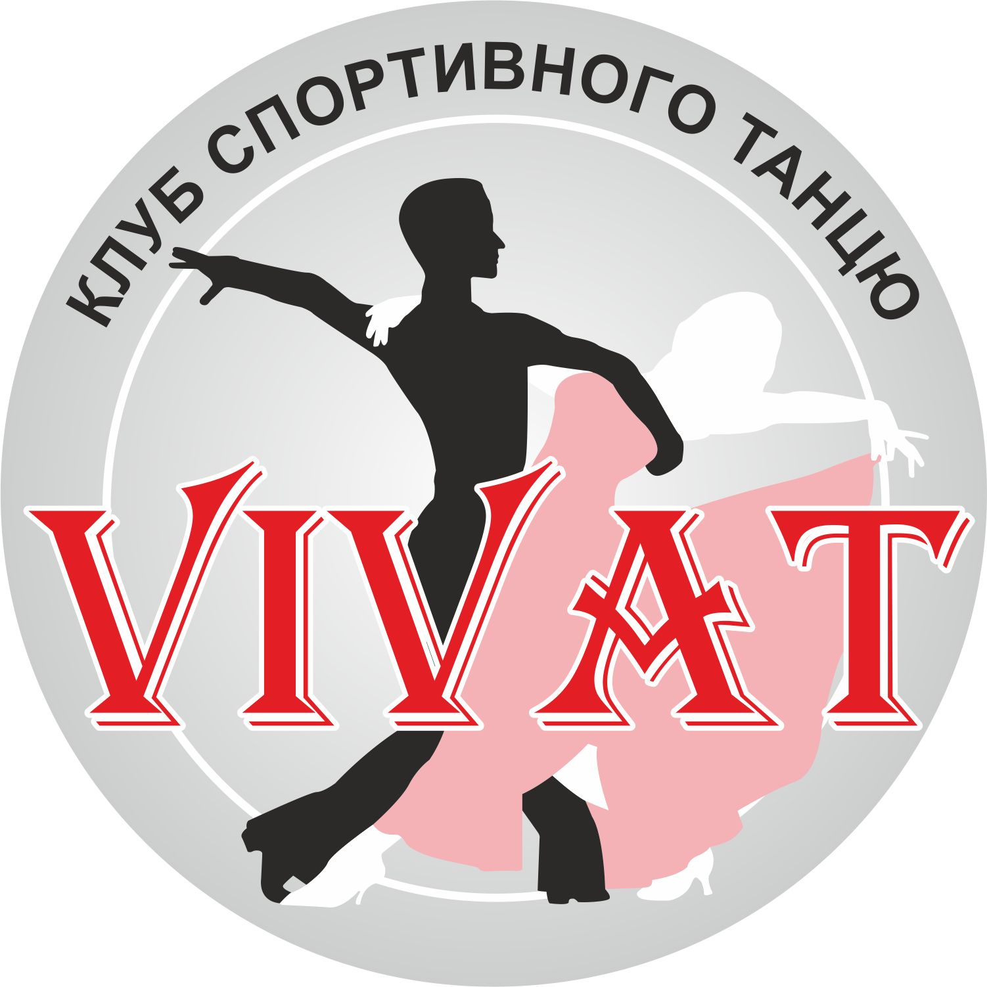
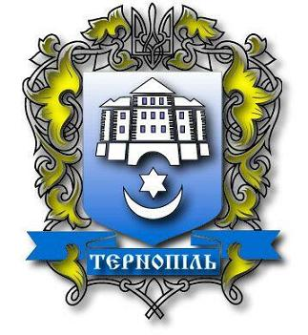
Ukrainian Dance Sport Association
Dance Club «VIVAT»
«CRYSTAL PROMENADE»
11 October 2014
Ternopil, Bilohirska 50 str, SportsComplex«POLITEKHNIK»

№ | CATEGORIES | 9:00- START OF COMPETITIONS | 13:30- START OF COMPETITIONS | 18:00- START OF COMPETITIONS
1 | Juveniles 1 “E” (under 10) | 3 ST, 3 LA
2 | Juveniles 2 “E” (under 12) | 3 ST, 3 LA
3 | Juniors 1 “E” (under 14) | 3 ST, 3 LA
4 | Juniors 2 “E” (under 16) | 3 ST, 3 LA
5 | Juveniles “D” (under 12) | 4 ST, 4 LA
6 | Juniors 1 “D” (under 14) |  | 4 LA | 4 ST
7 | Juniors 2 “D” (under 16) |  | 4 LA | 4 ST
8 | Youth “D” (under 19) |  | 4 ST | 4 LA
9 | Adult “D” (19 and older) |  | 4 ST | 4 LA
10 | Juveniles “С” (under 12) |  | ST, LA
11 | Juniors 1 “С” (under 14) |  | 5 LA | 5 ST
12 | Juniors 2 “С” (under 16) |  | 5 LA | 5 ST
13 | Youth “С” (under 19) |  | ST, LA
14 | Juveniles Open (under 12) |  |  | ST, LA
15 | Juniors 1 Open (under 14) |  | LA | ST
15 | Juniors 2 Open (under 16) |  | LA | ST
16 | Youth 1 Open (under 19) |  | ST | LA
17 | Youth 2 Open (under 21) |  | ST | LA
18 | Adult Open (21 and older) |  | ST | LA
19 | Team Match ( 2 couple ST,2 couple LA) |  |  | ST+LA

Entry fee: Per person per program:
Juveniles , Juniors, Youth, Adults Open – 150 UAH.;
Classification competitions: «E» - 100 UAH, «D», «C» - 120 UAH.;
Tickets: 80 UAH. for 1 separations
80 UAH. for 2 separations
80 UAH. for 3 (evening) separations - team match.

Prizes: All finalists of the competition will be rewarded by diplomas.
Prize-holders of the competition will be rewarded by diplomas, medals and cups.

Rules: According to WDC and UDSA Regulations.
Confirmations: http://reg.tancmir.com
Or send your mail vivat-dance@mail.ru until 9th of October.

Adjudicators: Jerry Abrate - Italy, Luka Tonello - Italy, Ekaterina Barulina - Russia, Boleslaw Bara - Poland, Olena Lemishko - Ukraine, Sergiy Francen– Ukraine, Lapteva Oleksandra – Ukraine, Prochko Yuriy - Ukraine and other invited WDC adjudicators.
On the evening separation Ukrainian Dress-code!!!

Table recervation: tel. 067 353 2773 Liliya

Organizator: Sport Dance Club "VIVAT" Pokidko Liliya, Karnas Taras, Pokidko Yuliya
e-mail: vivat-dance@mail.ru Тel.: 067 353 2773

