Artistic Dance

The World Championships Artistic Dancing
Granted by the WDC

Rimini (Italy) 28 e 29 Giugno 20134
Iscrizioni aperte fino al 15 Giugno 2014
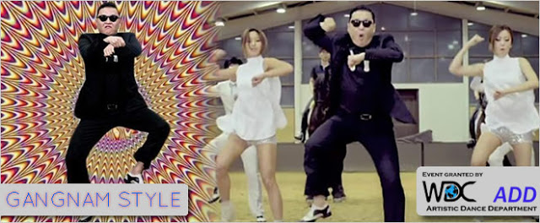
Sunday / Domenica/ Воскресенье 29th of June
09.00 Championship Doors open / Apertura porte per competizioni
10.00
. WORLD OPEN Choreografic Team CHAMPIONSHIP
WORLD OPEN Belly Dance CHAMPIONSHIP
WORLD OPEN Street Dance CHAMPIONSHIP
WORLD OPEN Formation Standard CHAMPIONSHIP
WORLD OPEN Formation Latin CHAMPIONSHIP
WORLD OPEN Disco Dance CHAMPIONSHIP
WORLD OPEN Hip Hop CHAMPIONSHIP
WORLD OPEN Dance Show CHAMPIONSHIP
WORLD OPEN Tecno CHAMPIONSHIP
WORLD OPEN Jazz Funk CHAMPIONSHIP
WORLD OPEN Jazz Modern CHAMPIONSHIP
WORLD OPEN Break Dance CHAMPIONSHIP
WORLD OPEN Boogie Boogie/ Rock n Roll CHAMPIONSHIP
WORLD OPEN Strip Plastic (Burlesque) CHAMPIONSHIP
WORLD OPEN Go – Go CHAMPIONSHIP
WORLD OPEN Salsa Dance CHAMPIONSHIP
WORLD OPEN Merengue Dance CHAMPIONSHIP
WORLD OPEN Rueda CHAMPIONSHIP

